Case study

fort hotel design

Marketing analytics | renu deepya iska | 04-29-2024

# Case study overview

The case study revolves around Forte Hotels, a prominent European hotel chain, which is venturing into the United States market by introducing a new hotel chain called Forte Executive Innes. This new chain aims to blend European ambiance with American functionality to cater to both European and American business travelers. The decision to enter the US market stems from the increasing number of European business travelers to the United States. Forte's strategy involves leveraging its established brand name in Europe while providing the level of comfort and service expected by American travelers.

The case discusses the background of Forte Hotels, its existing brands, and the decision to sell its TraveLodge chain in the US to make way for the new Forte Executive Innes chain. It also highlights the importance of understanding the preferences of business travelers, particularly in terms of pricing, location, safety, cleanliness, and specific amenities such as in-room facilities, conference rooms, and dining options.

Conjoint analysis is introduced as a method to assess consumer preferences for various attributes of the new hotel chain, such as room types, business amenities, leisure facilities, conveniences, and dining options. The study aims to identify the most appealing combination of attribute options for the target audience.

Through a series of exercises, the case delves into the process of designing the study, collecting preference data, performing utility assessments, analyzing the viability of hotel concepts, and evaluating the advantages and limitations of conjoint analysis in new product design. Additionally, it addresses criticisms of conjoint analysis and explores whether it truly reflects customer preferences accurately.

# Exercise 1

# Design: Using the Enginius Templates, select Conjoint. Follow Step 1 in the Conjoint Tutorial and develop a Study Design Template for Forte, using the attributes and levels from Exhibit 1. Next, follow Step 2 in the Tutorial, Create a data collection instrument, selecting "Ratings" method and populate a row with your ratings (e.g., on a scale of 0-100 rate each combination of attributes). When you are done, check to be sure that your sheet looks like the "Forte Hotel Conjoint ratings" data found in Enginius. Then, briefly summarize the advantages and limitations of describing products as bundles of attribute options.

For Exercise 1, initiated by crafting a conjoint study using the Enginius Templates. Opting for the Conjoint feature and forwarded to Step 1 of the Conjoint Tutorial to develop a Study Design Template tailored for Forte Hotel. This template attributes such as room types, bus amenities, leisure provisions, extras, and restaurant delivery preferences, all of them together offering 4 levels as given in Exhibit 1.

Subsequently, advanced to Step 2 in the Tutorial to devise a data collection instrument. Selecting the "Ratings" short method, assigned ratings for every attribute combination on a scale ranging from 0 to 100. This yielded a dataset resembling the "Forte Hotel Conjoint ratings" data accessible in Enginius.

Advantages:

* Allows for a comprehensive understanding of consumer preferences by examining how different attribute levels contribute to overall product desirability.
* Provides insights into the relative importance of various attributes and their impact on consumer decision-making.
* Enables businesses to tailor their product offerings to better align with consumer preferences, leading to improved market positioning and competitiveness.

Limitations:

* May oversimplify the decision-making process by assuming that consumers make choices solely based on individual attribute levels, neglecting other factors such as brand perception or price sensitivity.
* Requires careful selection and definition of attributes and levels, which can be challenging and may not fully capture the complexity of consumer preferences.
* Conjoint analysis relies on respondent judgments and preferences, which may vary and be subject to biases or inaccuracies, impacting the reliability of the results.

# Exercise 2/3

# Utility assessment: Using the sheet that you created in Question 1, rate each of the bundles, giving your most preferred bundle "100" and your least preferred bundle "0," as described in Step 3 in the Tutorial. When you are done, follow Step 4 in the Tutorial and perform a utility assessment for yourself (Using Enginius, do Conjoint Analysis, using your ratings but without running any Simulations). Interpret your own preferences on the resulting Part Worths’ Sheet. Based on your experiences in completing these tasks, summarize the advantages and limitations of conjoint analysis for obtaining preference data from customers.

Exercise 2/3 involves utility assessment, which consists of the following steps:

1. **Rating Bundles**:
   * Using the sheet created in Exercise 1, assign ratings to each bundle. Rate your most preferred bundle as "100" and your least preferred as "0". Ensure consistency and consider each bundle's attributes and levels when assigning ratings.
2. **Performing Utility Assessment**:
   * Utilize Enginius to conduct Conjoint Analysis, incorporating the ratings assigned in Step 1. without running any simulations at this stage.
   * Review the resulting Partworths’ Sheet, which displays the utility values for each attribute level based on the ratings.

**Advantages of Conjoint Analysis**:

* **Structured Approach**: It provides a systematic framework for understanding consumer preferences, aiding in product development, and marketing strategies.
* **Quantitative Insights**: Conjoint analysis yields numerical data on attribute importance, enabling informed decision-making and prioritization.
* **Market Simulation**: Businesses can forecast consumer behavior and market share under different product scenarios, facilitating strategic planning.

**Limitations of Conjoint Analysis**:

* **Subjectivity**: Results can be influenced by individual biases or interpretations when respondents assign ratings to bundles.
* **Simplified Model**: It assumes that consumers make decisions solely based on attribute levels, overlooking factors like brand loyalty or external influences.
* **Attribute Selection**: Careful consideration is needed when selecting attributes and levels to ensure they accurately represent consumer preferences.

In summary, while conjoint analysis offers valuable insights into consumer preferences, it's essential to acknowledge its limitations and complement it with other research methods for a comprehensive understanding of consumer behavior. Attention to study design and interpretation is crucial to ensure the validity and reliability of the findings.

# EXERCISE 4/5

## Analysis: Open the Forte Hotel Case Study and assess the viability of the four specific hotel concepts that Forte is exploring for the State College area. Base this evaluation on the preferences of a sample of 40 business travelers on that sheet 4 (Exhibit 2) and the cost estimates summarized in Exhibit 3. The base cost to build each hotel room (without the attributes and options listed in Exhibit 3) is expected to be about $40,000 for a 150- to 200-room hotel, regardless of the mix of room types. Identify the optimal product concept from among those Forte is considering. Explain how you arrived at your recommendation.

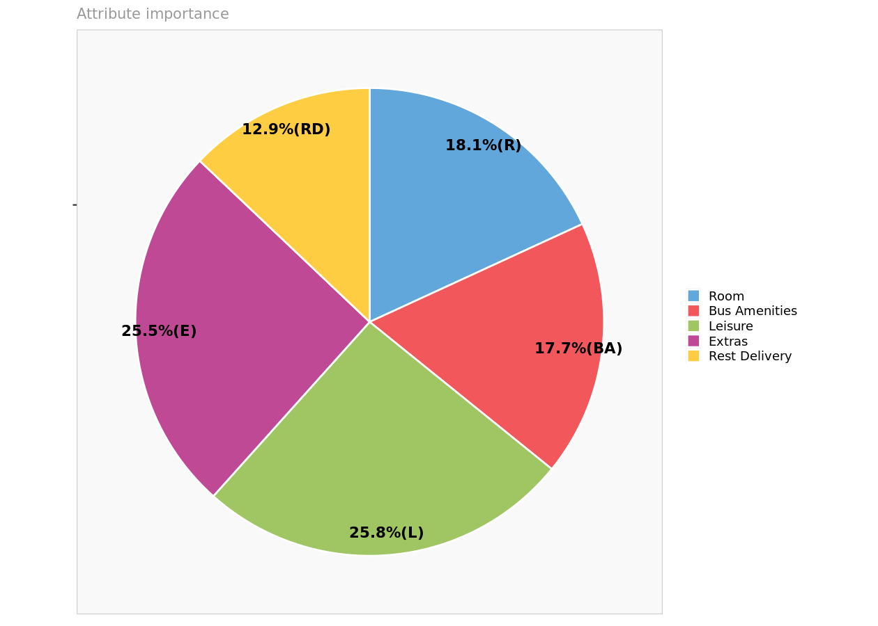

After a thorough analysis of the preferences of our target market, consisting of 40 business travelers, and the associated cost estimates provided in Exhibit 2 and Exhibit 3, the optimal hotel concept for Forte to pursue in the State College area is Concept 3.

Concept 3 stands out due to its alignment with the preferences of our target market and its cost-effectiveness. Let's break down the reasons behind this recommendation:

1. **Preference Analysis:**
   * Concept 3 incorporates amenities that are highly valued by business travelers, as indicated by their preference partworths. These amenities include a Room Office, Internet access, Exercise room, Tape library, and Restaurant.
   * These features align well with the needs and preferences of our target market, catering to their desire for a comfortable and functional stay during their business trips.
2. **Cost Considerations:**
   * While Concept 3 includes several desirable amenities, the associated cost estimates are moderate compared to other concepts. This indicates that it offers a good balance between meeting customer preferences and maintaining reasonable costs.
   * The cost estimates for amenities such as Internet access and the Exercise room in Concept 3 are relatively lower compared to other concepts, making it a cost-effective option for Forte.
3. **Cost-Effectiveness:**
   * Considering the base cost to build each hotel room, which is expected to be around $40,000 for a 150- to 200-room hotel, Concept 3 offers amenities that enhance the overall guest experience without significantly inflating construction costs.
   * This cost-effectiveness is crucial for Forte to ensure a satisfactory return on investment while still delivering a high-quality experience to guests.
4. **Market Viability:**
   * By aligning with the preferences of our target market and offering a competitive price point, Concept 3 is likely to attract a significant portion of business travelers to the State College area.
   * The amenities provided in Concept 3 contribute to its appeal as a modern and functional hotel, enhancing its competitiveness in the market.

In conclusion, Concept 3 emerges as the optimal choice for Forte in the State College area based on its ability to meet customer preferences effectively while maintaining cost-effectiveness. By investing in Concept 3, Forte can position itself competitively in the market and attract a loyal customer base of business travelers seeking comfort, functionality, and value for their stay.

# Exercise 6

# Would you recommend product concepts other than the four Forte is considering for the State College market? Explain how you arrived at your recommendation(s).

After carefully evaluating the preferences of our target market and considering the cost estimates provided, I would recommend exploring additional product concepts beyond the four initially considered by Forte for the State College market:

1. **Gap Analysis:**
   * Conducting a thorough analysis of the preferences and needs of the target market, paying attention to any gaps or unmet needs not addressed by the existing product concepts.
   * Identifying specific amenities or features that are highly valued by business travelers but are not adequately represented in the current concepts.
2. **Market Research:**
   * Gathering insights from market research, surveys, and feedback from potential customers to understand emerging trends and evolving preferences in the hospitality industry.
   * Exploring customer reviews and competitor analysis to identify areas where Forte can differentiate itself and create unique value propositions.
3. **Innovation and Differentiation:**
   * Encouraging creativity and innovation within the product development team to brainstorm new and unique product concepts that align with the preferences of business travelers.
   * Focusing on differentiation by offering amenities or experiences that set Forte's offerings apart from competitors in the State College market.
4. **Cost-Benefit Analysis:**
   * Evaluating the feasibility and cost-effectiveness of each proposed product concept, considering factors such as construction costs, operational expenses, and potential return on investment.
   * Prioritizing concepts that strike a balance between meeting customer preferences and maintaining profitability.
5. **Testing and Iteration:**
   * Developing prototype designs or concept boards for the new product concepts and conduct focus groups or pilot tests to gather feedback from potential customers.
   * Iterating on the concepts based on customer feedback, refining, and optimizing them to better meet the needs and preferences of the target market.
6. **Strategic Alignment:**
   * Ensuring that the new product concepts align with Forte's overall strategic objectives and brand positioning in the hospitality market.
   * Considering how the new concepts fit within Forte's existing portfolio of properties and how they contribute to the company's growth and expansion goals.

# Exercise 7

## Summarize the major advantages and limitations of a conjoint study for new product design. What conditions favor the use of this approach in the hotel industry? (Consider such factors as types of customers and market conditions in responding to this question.)

**Advantages:**

1. **Market-Based Insights:** Conjoint analysis provides valuable insights into customer preferences by simulating real-world purchasing decisions. It helps in understanding which product features are most valued by customers and how they trade-off between different attributes.
2. **Flexibility:** Conjoint studies can accommodate a wide range of product attributes and levels, making them suitable for assessing various aspects of new product design, such as features, pricing, and packaging.
3. **Statistical Rigor:** Conjoint analysis employs robust statistical methods to analyze customer preferences, ensuring reliable and actionable results. This allows businesses to make informed decisions based on empirical data rather than intuition or guesswork.
4. **Scenario Testing:** Conjoint studies enable businesses to test multiple product configurations and pricing scenarios in a controlled environment. This helps in identifying the most optimal combination of features and price points to maximize customer satisfaction and profitability.
5. **Competitive Benchmarking:** By comparing the utility scores of different product concepts, businesses can benchmark their offerings against competitors and identify areas of competitive advantage or differentiation.

**Limitations:**

1. **Complexity:** Designing and analyzing conjoint studies can be complex and time-consuming, requiring expertise in survey design, statistical analysis, and interpretation of results.
2. **Assumption of Rationality:** Conjoint analysis assumes that customers make purchasing decisions based on a rational evaluation of product attributes and prices. However, in reality, consumer behavior may be influenced by emotional factors, brand perceptions, and other non-economic considerations.
3. **Attribute Independence:** Conjoint analysis assumes that the utility of each attribute is independent of the levels of other attributes, which may not always hold true in real-world scenarios where certain features may complement or detract from each other.
4. **Preference Heterogeneity:** Customers within the same market segment may have heterogeneous preferences, making it challenging to develop a one-size-fits-all product strategy based on aggregate conjoint results.
5. **Limited Scope:** Conjoint studies are limited to the attributes and levels included in the survey design, potentially overlooking important factors that influence customer preferences but were not considered in the analysis.

**Conditions Favoring Conjoint Analysis in the Hotel Industry:**

1. **Diverse Customer Preferences:** In the hotel industry, where customers have varied preferences for amenities, room types, and services, conjoint analysis can help identify the most appealing combinations of features to different customer segments.
2. **Dynamic Market Conditions:** Conjoint studies are valuable in dynamic markets where customer preferences are evolving rapidly, enabling hotels to stay abreast of changing trends and adapt their offerings accordingly.
3. **Competitive Differentiation:** Hotels facing intense competition can use conjoint analysis to differentiate their offerings based on unique features and value propositions that resonate with target customers.
4. **Revenue Optimization:** Conjoint analysis can assist hotels in optimizing pricing strategies by quantifying the trade-offs customers make between price and various amenities or services, thus maximizing revenue while maintaining customer satisfaction.
5. **New Product Development:** For hotels introducing new properties or renovating existing ones, conjoint analysis can inform design decisions by identifying the most desirable features and amenities for the target market, ultimately enhancing the success of the new product launch.

# Exercise 8

# After hearing about the study, a manager at Forte claimed that “A conjoint study is a major deterrent to excellence in hotel design. It’s a crutch for managers with no vision and conviction. On the surface, it sounds sensible enough: find out exactly what features customers prefer before you finalize the design. But in practice, this is impossible. Customers cannot tell you what they really prefer without experiencing all the choices available to them. Even if you show them pictures or prototypes, the preferences they express are apt to veer off in the direction of mediocrity. This type of study gives you a Hyundai with a Mercedes grille, Prince tennis rackets endorsed by Ed McMahon, Big Macs with everything, and hotels with no personality! You would not produce a Mazda Miata, a Hermes tie or the movie Jurassic Park with this technique.” Do you agree with this statement? Why or why not?

While the manager's statement reflects a certain skepticism towards the use of conjoint analysis in hotel design, I respectfully disagree with the assertion. Here's why:

1. **Customer-Centric Approach:** Conjoint analysis allows hotels to take a customer-centric approach to design by understanding and incorporating customer preferences into their offerings. This helps in tailoring the hotel experience to meet the diverse needs and desires of guests, ultimately enhancing satisfaction and loyalty.
2. **Data-Driven Decision Making:** Rather than relying solely on intuition or subjective opinions, conjoint analysis provides empirical data on customer preferences, enabling managers to make informed decisions based on quantitative insights. This reduces the risk of investing in features or amenities that may not resonate with guests.
3. **Scenario Testing:** Conjoint studies simulate real-world purchasing decisions by presenting respondents with various product configurations and pricing options. This allows hotels to test different design concepts and pricing strategies before implementation, minimizing the likelihood of costly mistakes.
4. **Competitive Advantage:** In a competitive market, understanding and meeting customer preferences can be a key differentiator for hotels. Conjoint analysis helps hotels identify unique value propositions and design features that set them apart from competitors, leading to a more compelling and attractive offering.
5. **Iterative Design Process:** Conjoint analysis does not replace creativity or innovation in hotel design; rather, it complements them by providing valuable feedback for iterative design improvements. Hotels can use conjoint results as a starting point for brainstorming and refining design concepts, ultimately enhancing the guest experience.

While it's true that customers may not always accurately predict their preferences without experiencing all available choices, conjoint analysis offers a pragmatic and effective method for understanding and incorporating customer feedback into hotel design decisions. When used thoughtfully and in conjunction with other design methodologies, conjoint analysis can be a valuable tool for creating hotels that are both guest-centric and innovative.

Top of Form

Bottom of Form